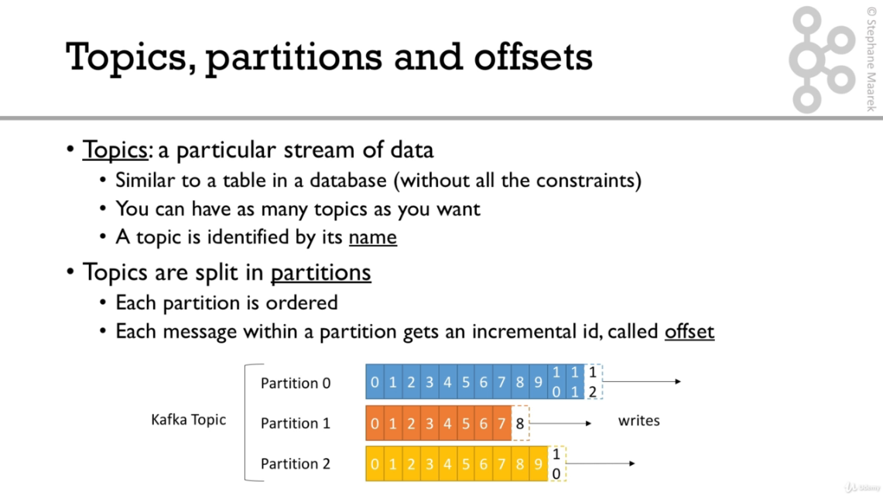

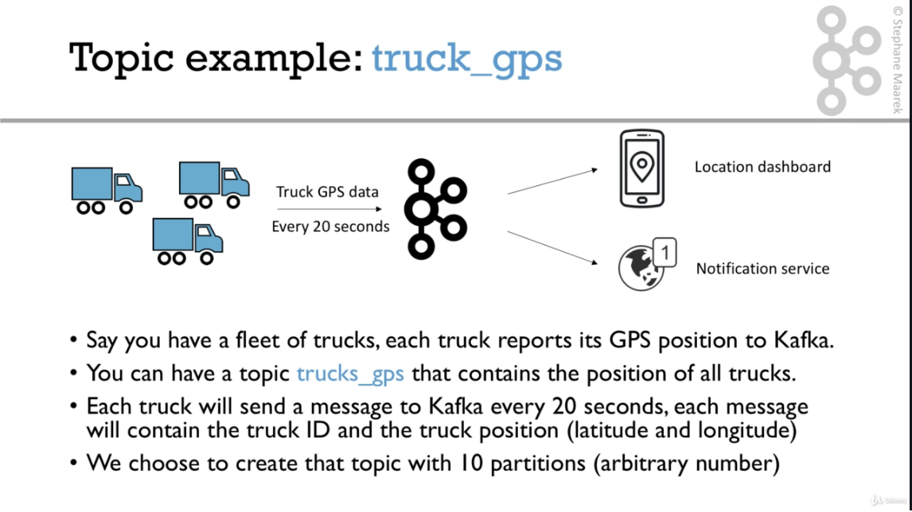

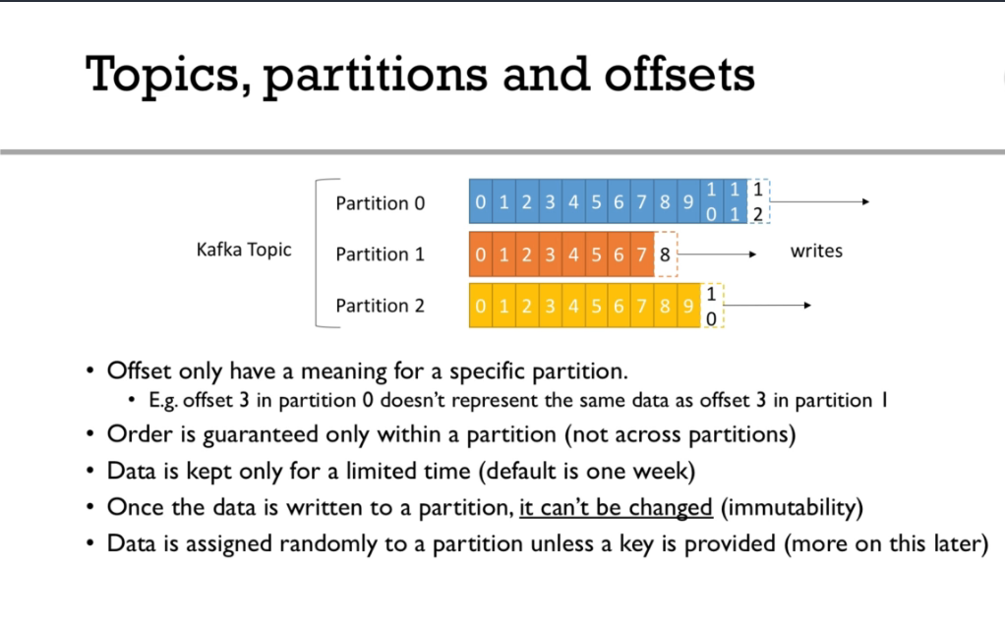

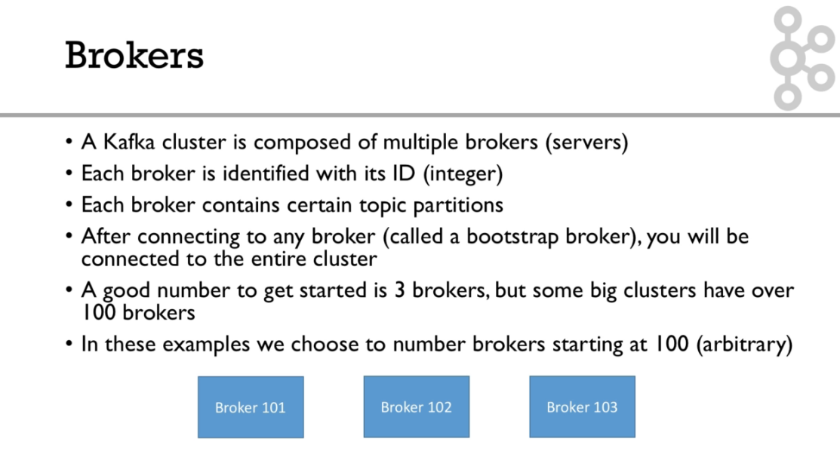

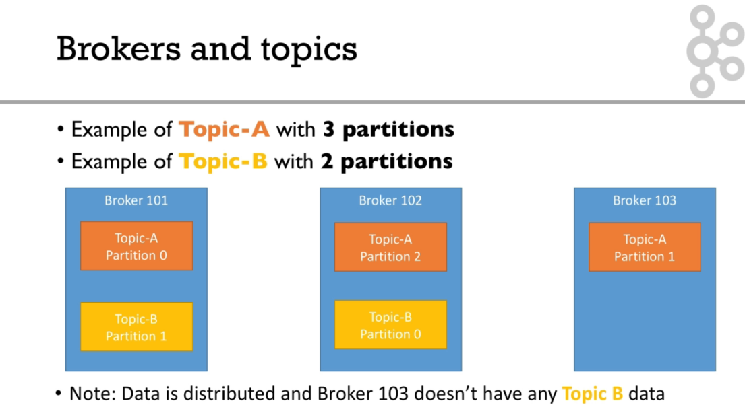

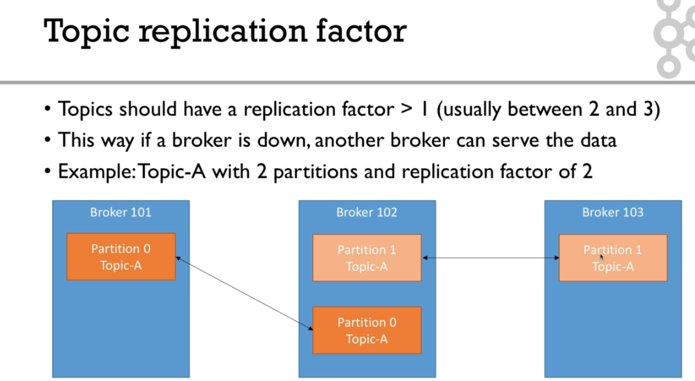

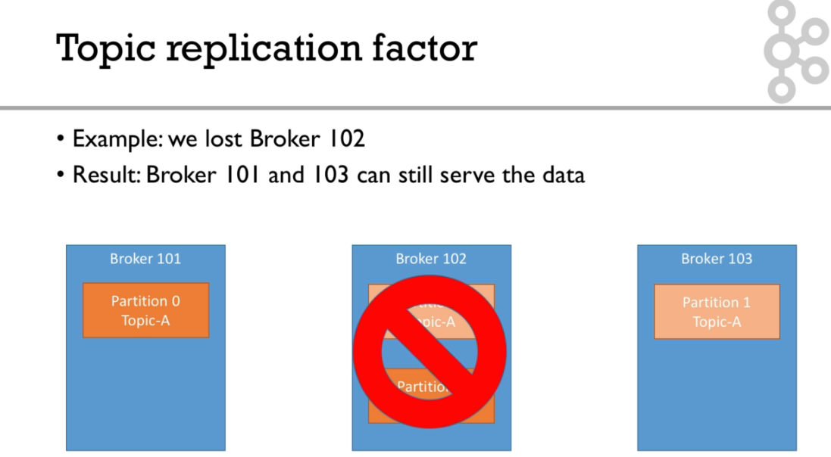

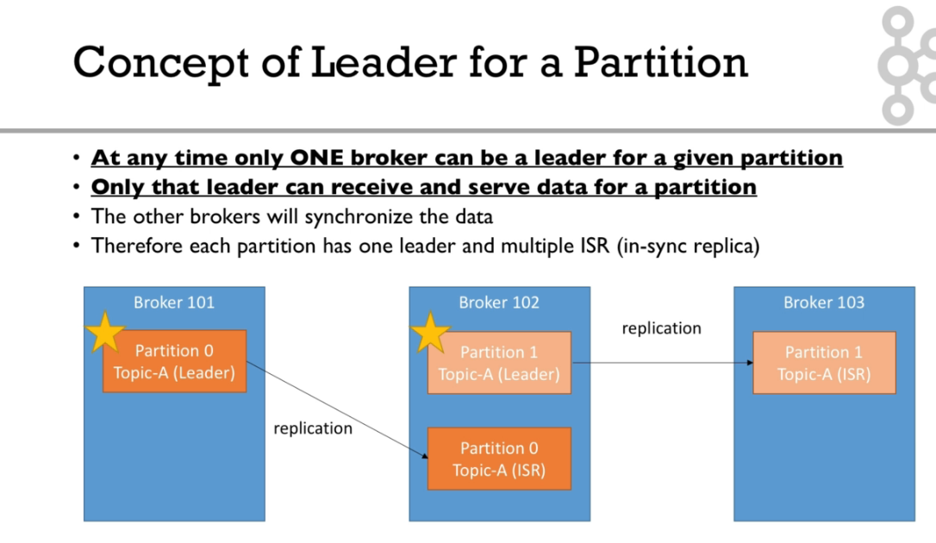

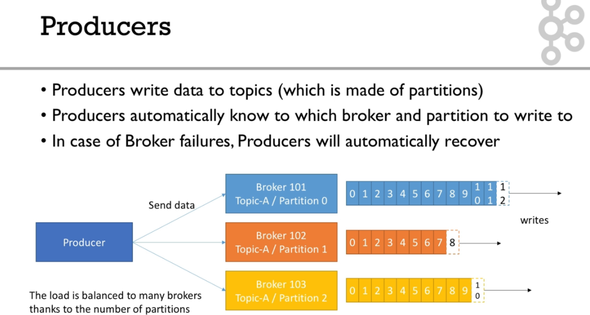

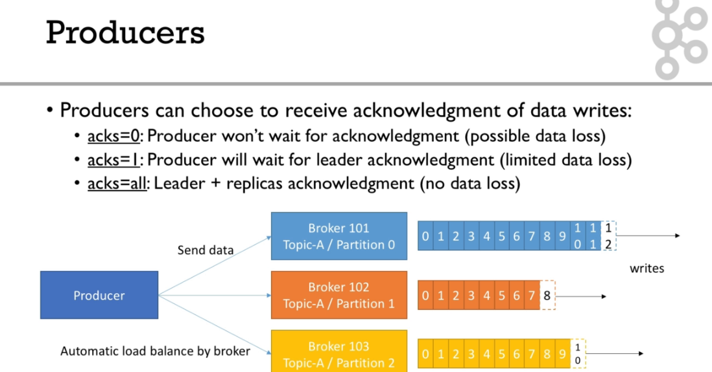

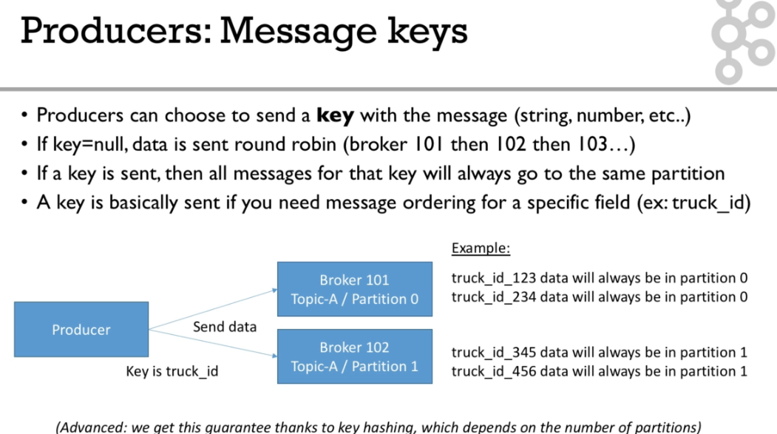

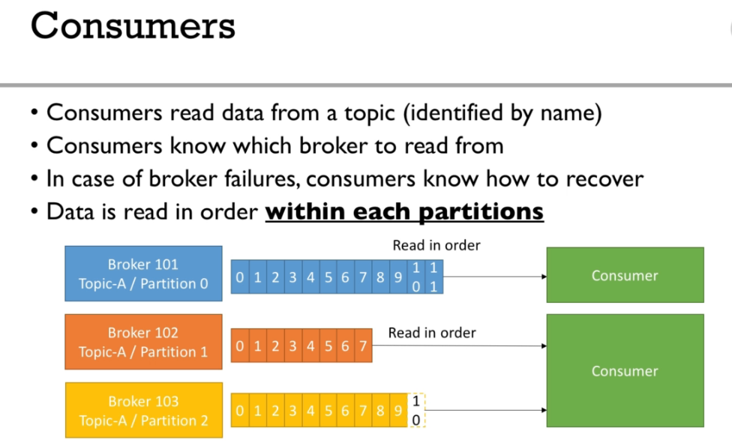

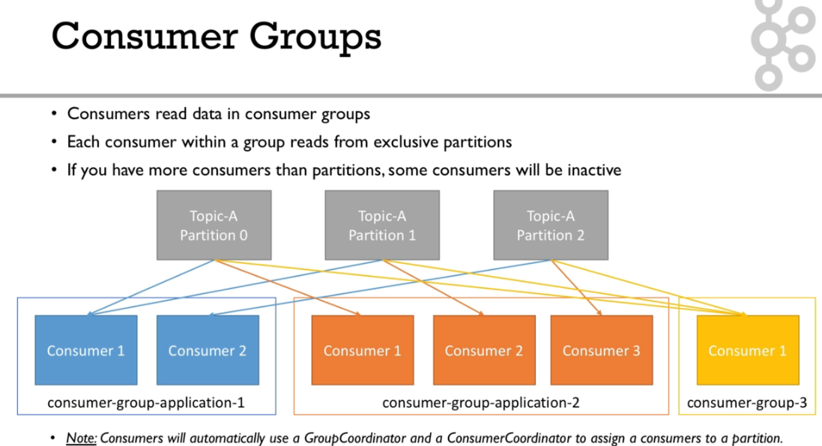

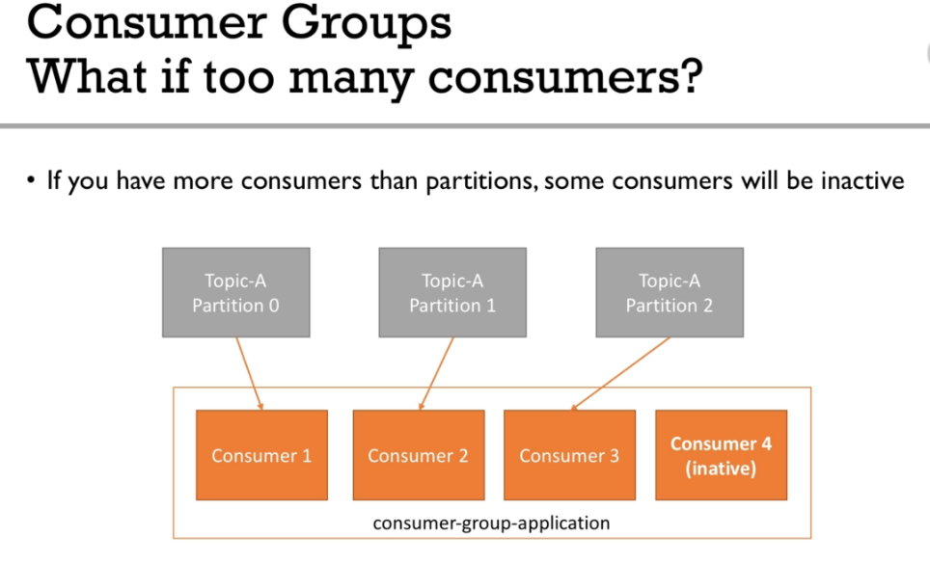

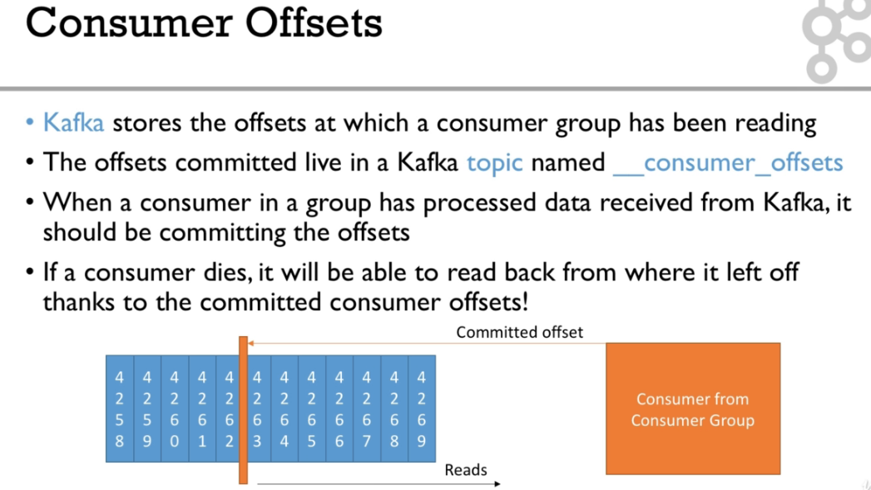

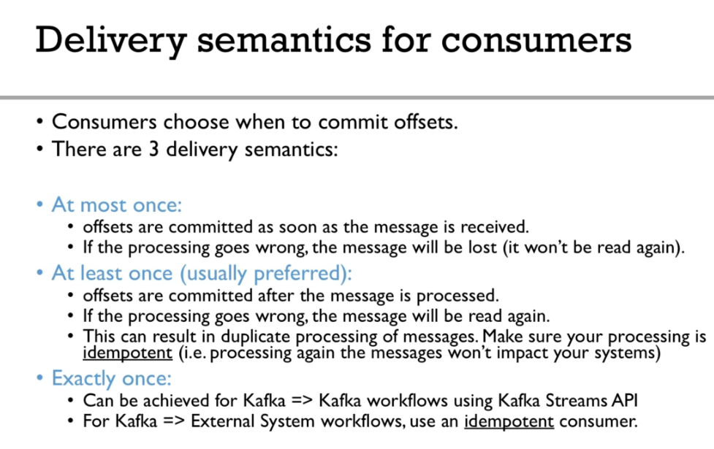

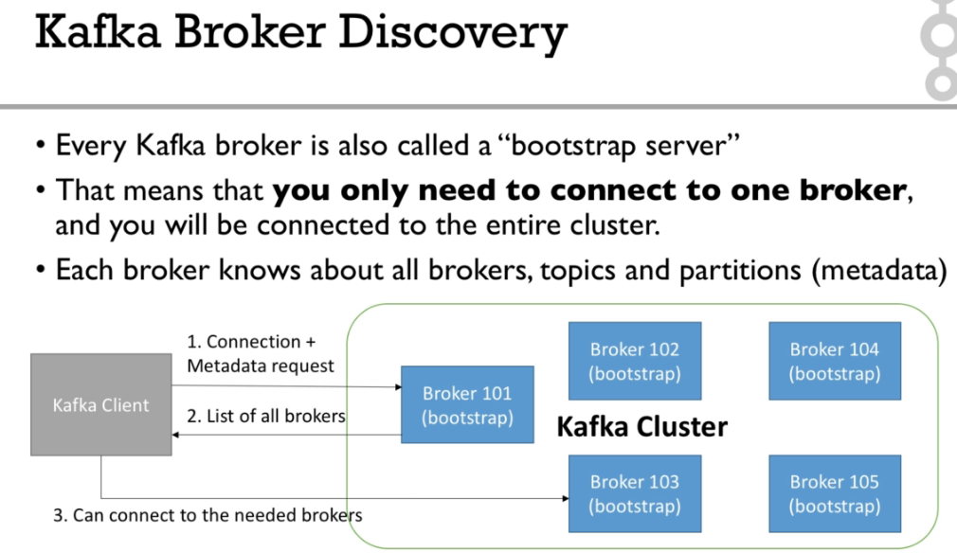

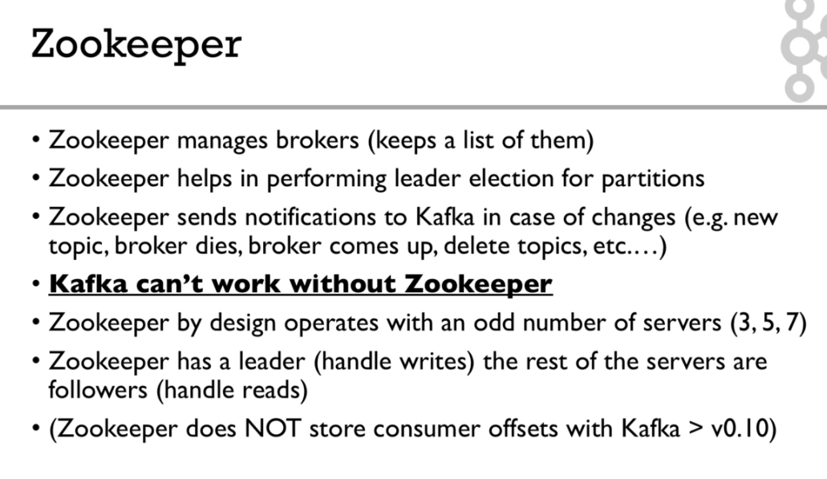

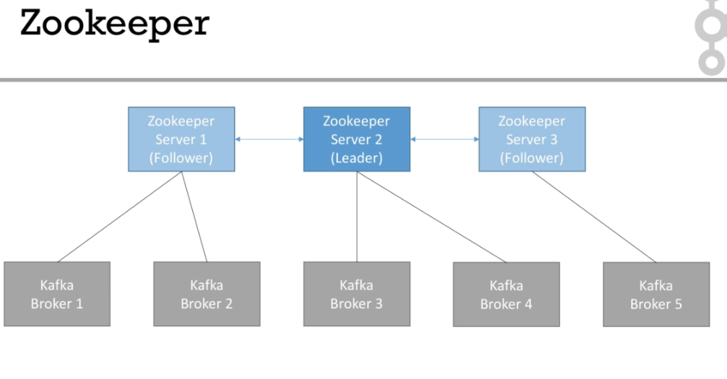

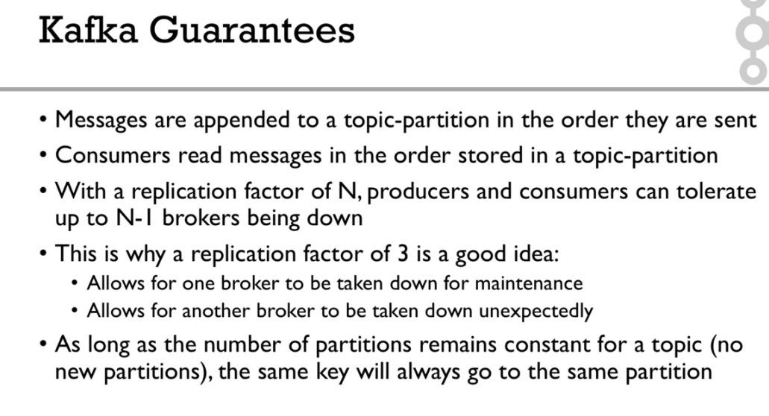

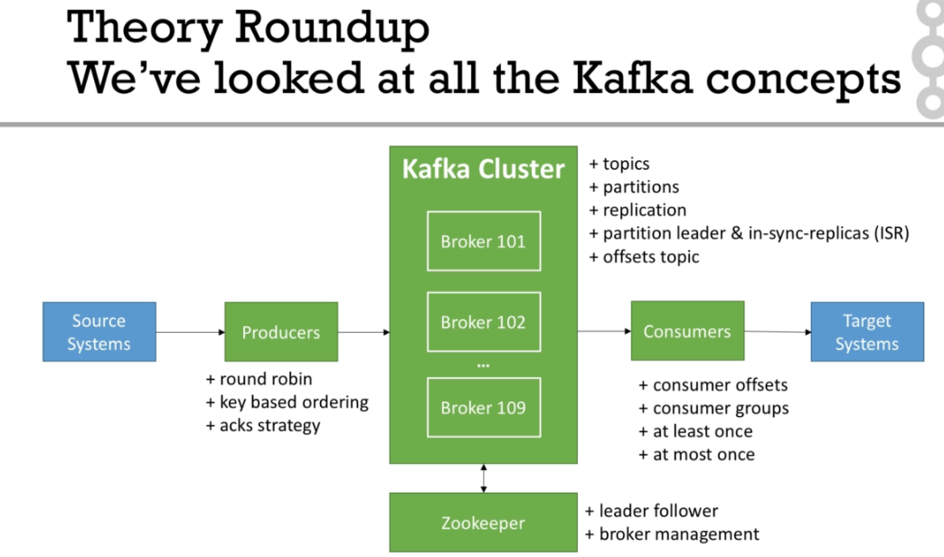

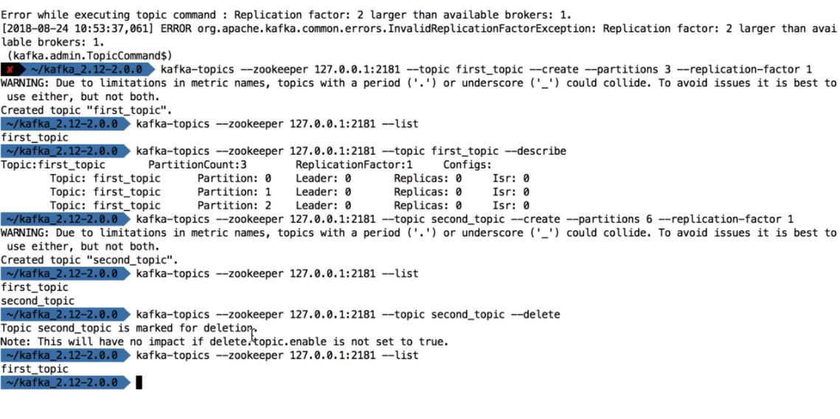

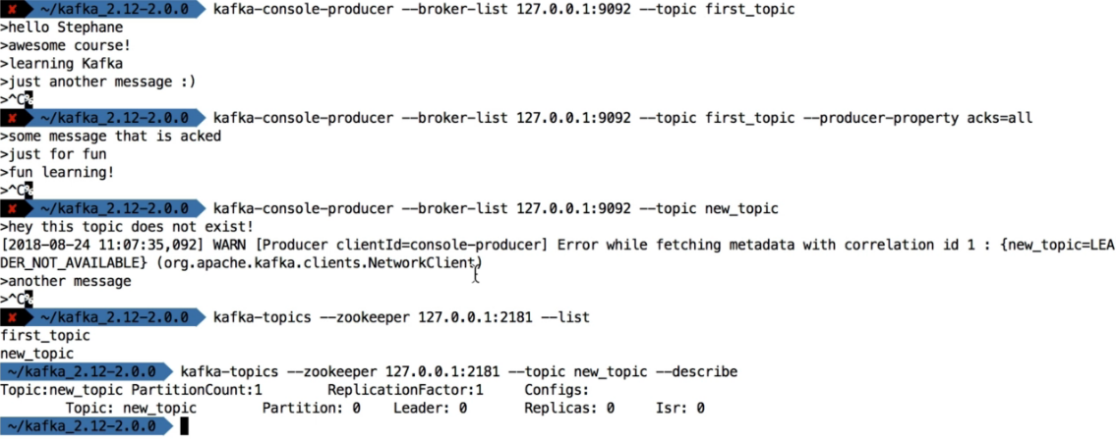

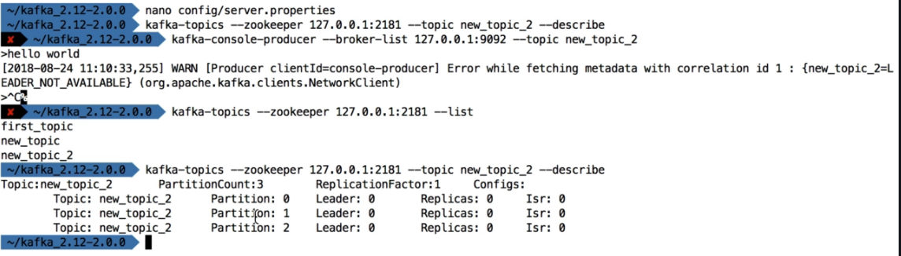

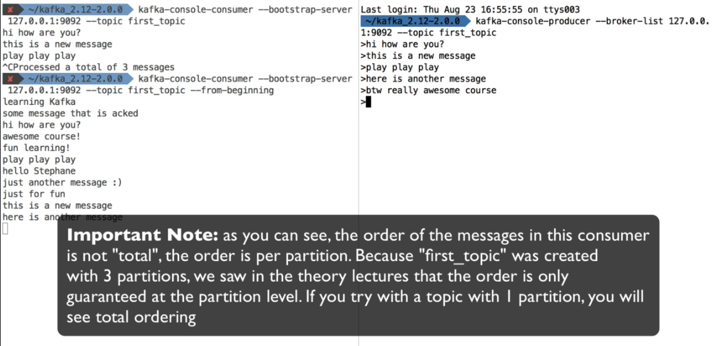

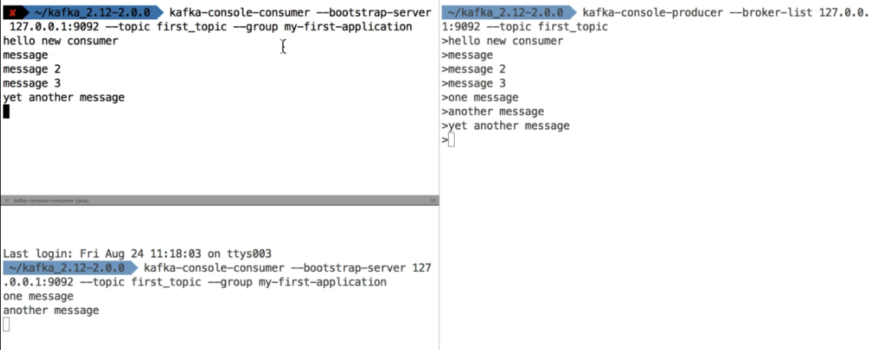

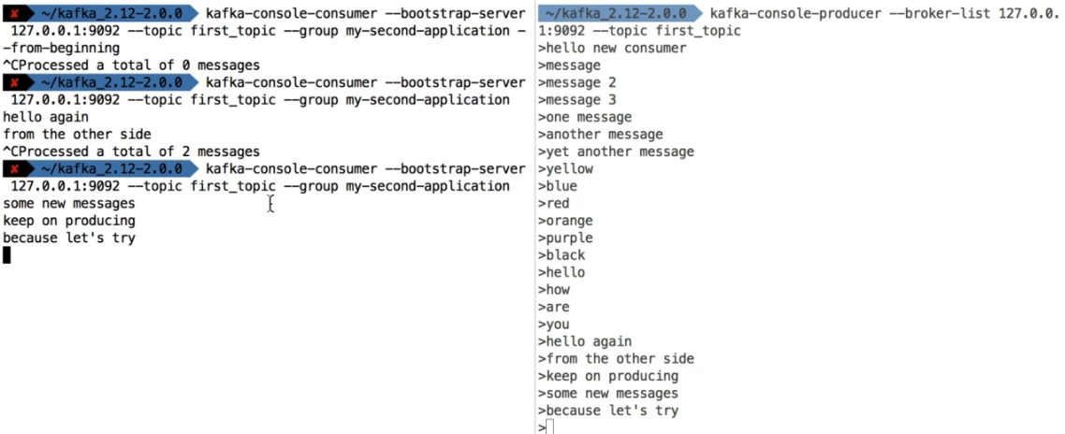

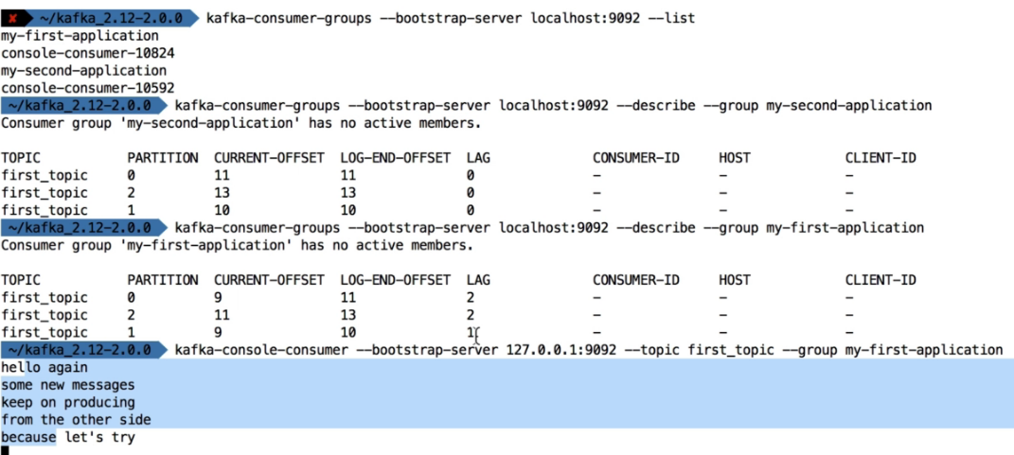

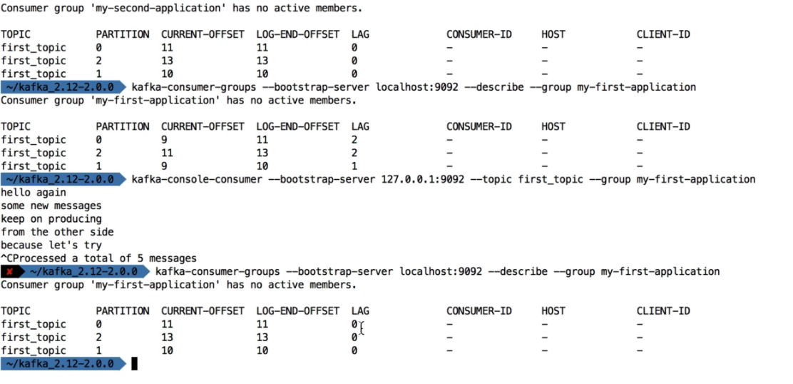

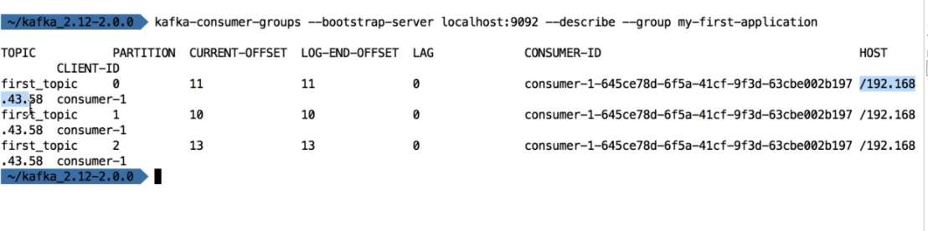

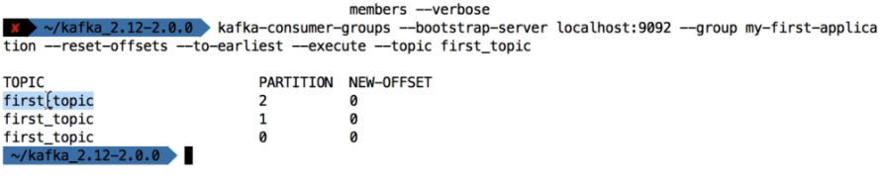

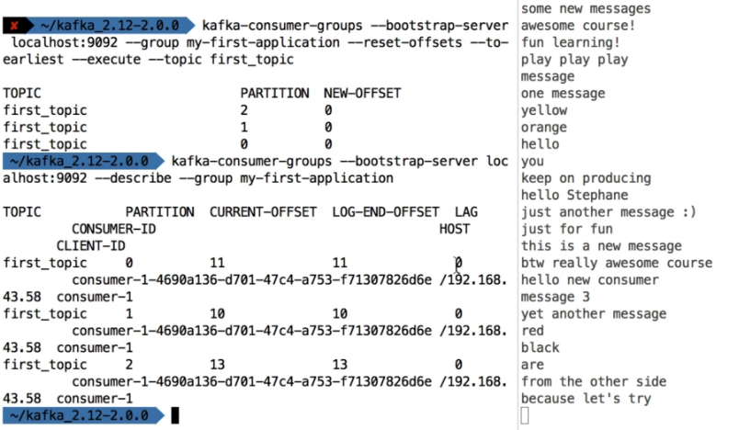

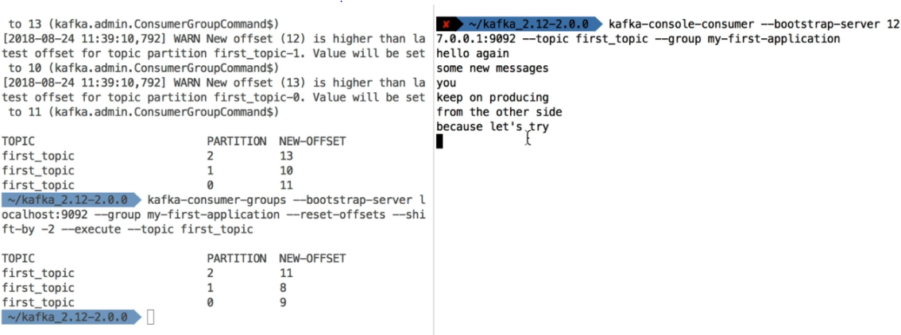

CLI Options that are good to know

**The CLI have many options, but here are the other that are most commonly used:**

Producer with keys

1. kafka-console-producer --broker-list 127.0.0.1:9092 --topic first_topic --property parse.key=true --property key.separator=,
2. > key,value
3. > another key,another value

Consumer with keys

1. kafka-console-consumer --bootstrap-server 127.0.0.1:9092 --topic first_topic --from-beginning --property print.key=true --property key.separator=,

What about UIs?

**Kafka does not come bundled with a UI, but here are some recommendations**

* Kafka Manager (for managing Kafka and instead of using CLI): <https://github.com/yahoo/kafka-manager>
* Kafka Tools (will be explore in the next lecture)
* You may find other UIs on the internet

**Overall in this course, we perform all the actions without any UI, which is good for learning how to properly use the CLI**

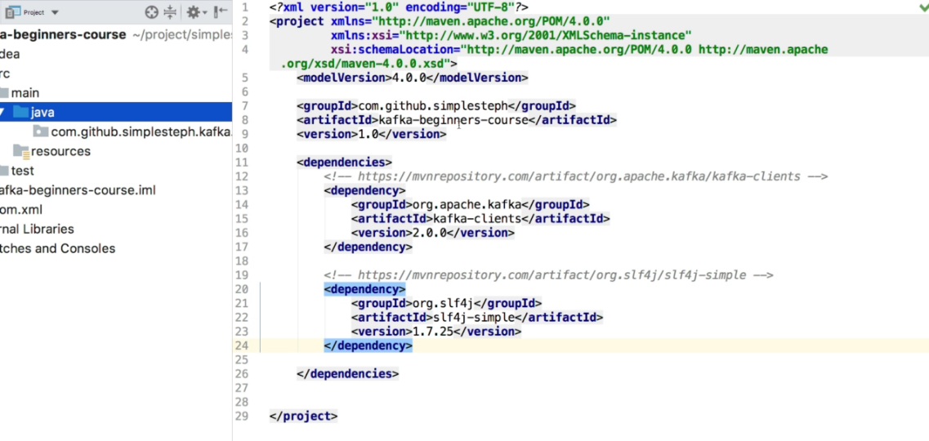

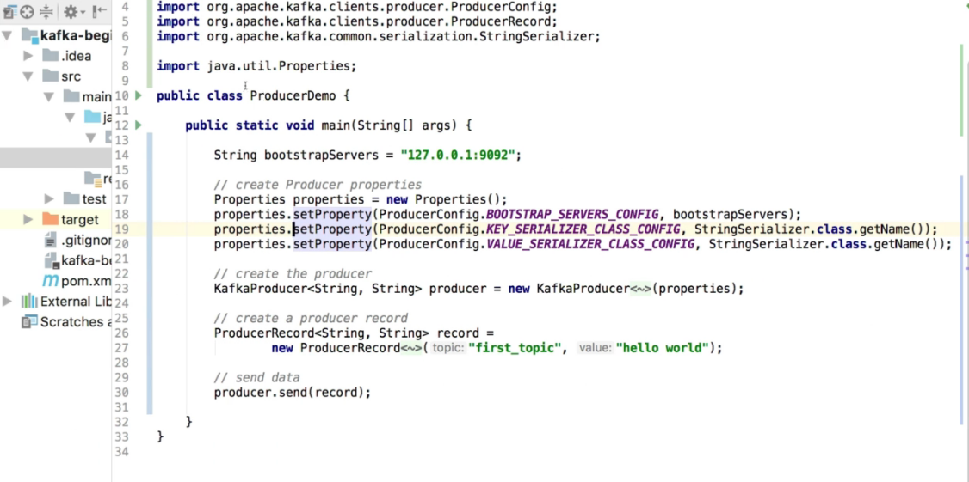

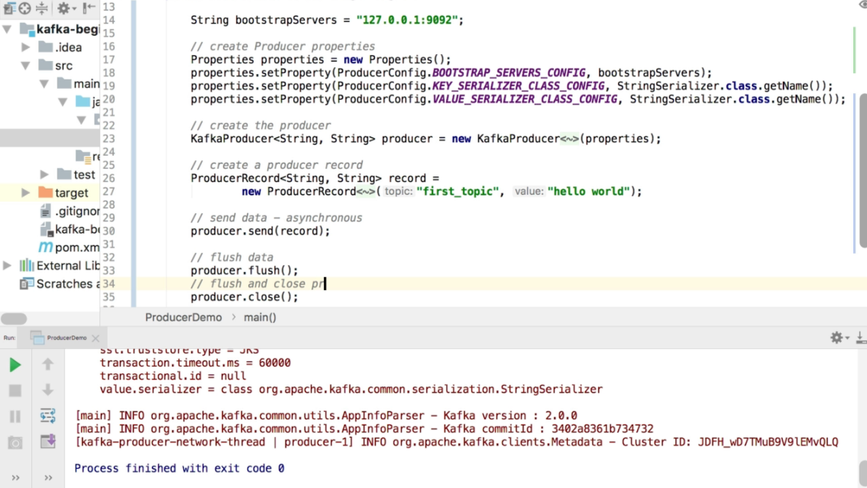

Start console consume on same topic

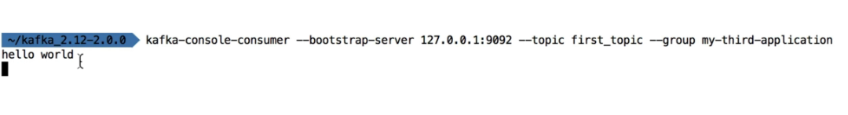

ProducerWithCallback:

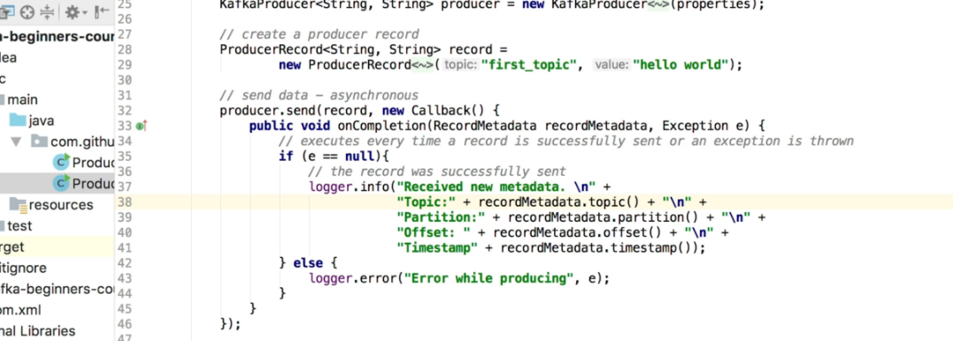

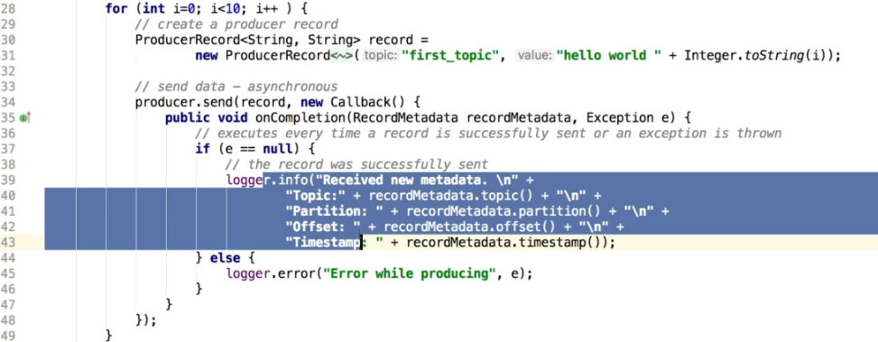

ProducerWithKEYs:

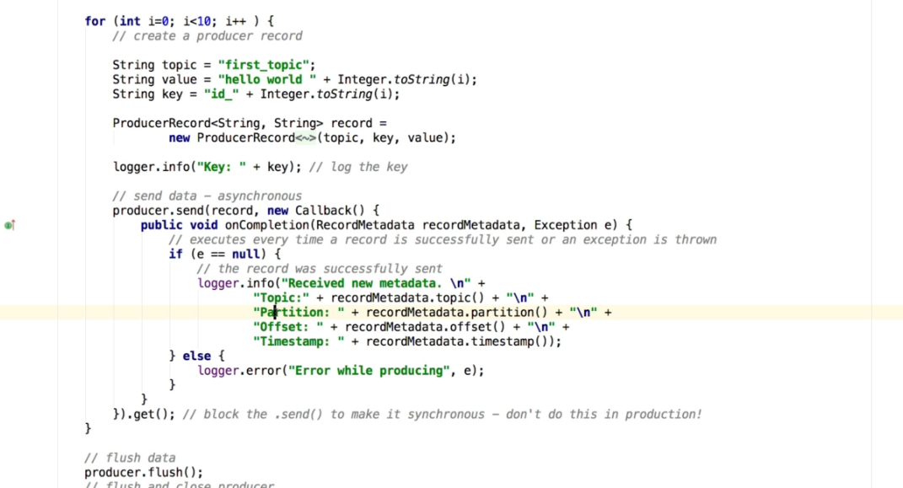

Consumer:

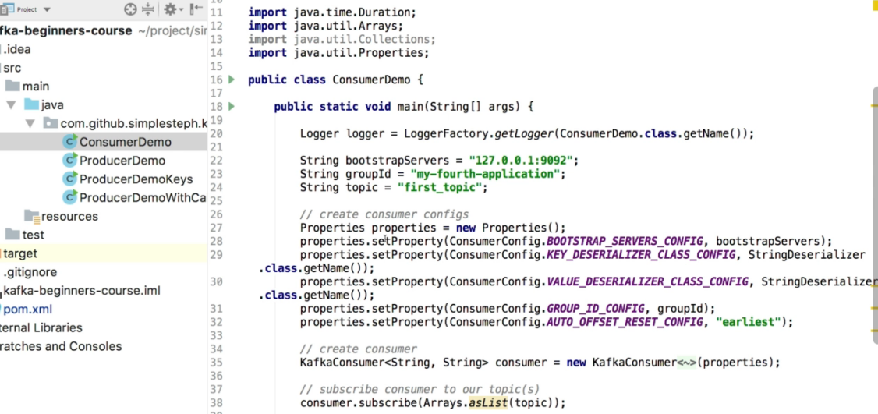

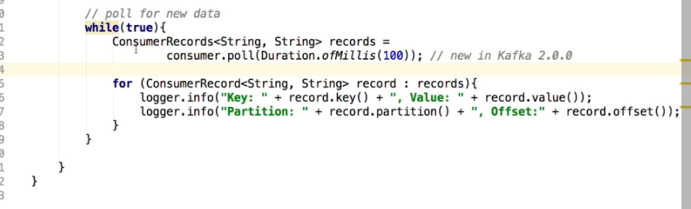

Consumer Group

Launch multiple consumer and demonstriate how the partitions are distributed

Consumer with thread:

<https://github.com/simplesteph/kafka-beginners-course>

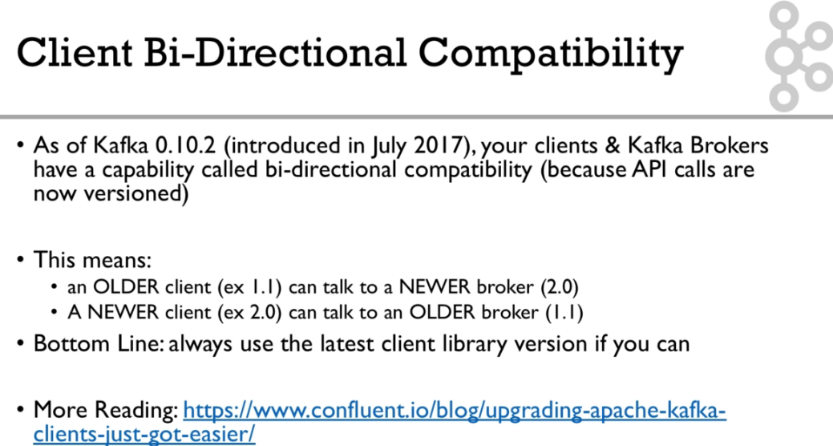

. Configuring Producers and Consumers

**Client Configurations**

There exist a lot of options to:

* configure producer: <https://kafka.apache.org/documentation/#producerconfigs>
* configure consumers:  <https://kafka.apache.org/documentation/#consumerconfigs>

**The most important options are discussed in the real-world project section, coming next**

Happy learning!

Real World Exercise

**Real-World Exercise:**

Before jumping to the next section for the solution, here are some pointers for some exercises:

**Twitter Producer**

*The Twitter Producer gets data from Twitter based on some keywords and put them in a Kafka topic of your choice*

* Twitter Java Client: <https://github.com/twitter/hbc>
* Twitter API Credentials: <https://developer.twitter.com/>

**ElasticSearch Consumer**

*The ElasticSearch Consumer gets data from your twitter topic and inserts it into ElasticSearch*

* ElasticSearch Java Client: <https://www.elastic.co/guide/en/elasticsearch/client/java-rest/6.4/java-rest-high.html>
* ElasticSearch setup:
  + <https://www.elastic.co/guide/en/elasticsearch/reference/current/setup.html>
  + OR <https://bonsai.io/>

**Good luck!**